TC-CUS-005
Before Update :
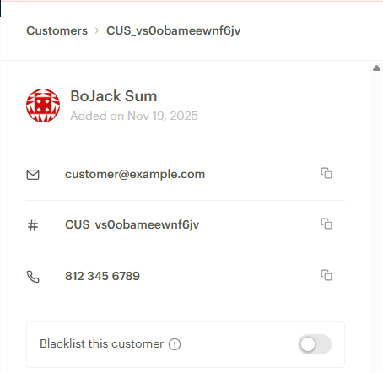
Request:
{
"first_name": "KB",
"last_name": "Mgazi"
}

Response:
{
"status": true,
"message": "Customer updated",
"data": {
"first_name": "KB",
"last_name": "Mgazi",
"email": "customer@example.com",
"phone": "+2348123456789",
"metadata": {},
"domain": "test",
"customer_code": "CUS_vs0obameewnf6jv",
"risk_action": "default",
"id": 320161482,
"integration": 1642714,
"createdAt": "2025-11-19T16:15:09.000Z",
"updatedAt": "2025-11-19T16:36:29.000Z",
"identified": false,
"identifications": null
}
}

